**Autonomic Nervous system viva**

Alex Hunter 2020

*Opening question read exactly:*

**Q) What is the autonomic nervous system?**

The autonomic nervous system (ANS) is the part of the nervous system that regulates involuntary functions.

**Q) How is the ANS organised?**

Based on a reflex arc

* Afferent (eg chemoreceptor/ baroreceptor) sensing input stimulus
* Efferent preganglionic, postganglionic fibres and an autonomic ganglion.

Efferent pathway fibres can be sympathetic or parasympathetic.

**Q) Discuss the structure of the sympathetic nervous system**

* Thoraco-lumbar outflow
* Myelinated preganglionic fibres synapse with sympathetic ganglion
* These form a chain of paraveterbral ganglio
* Post ganglionic fibres leave with spinal and visceral nerve to target effector organs.

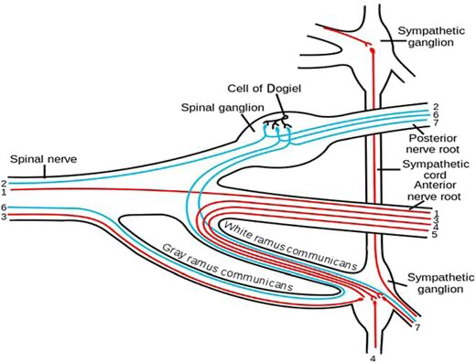

**Q) Describe the anatomy of the sympathetic paravertebral chain**

* Cervical part supplies head, neck, thorax – Stellate ganglion
* Thoracic part supplies aortic, cardiac and pulmonary plexus
* Lumbar part form the coeliac plexus
* Pelvic part – sacral ganglia

**Q) Discuss the structure of the parasympathetic nervous system**

* Myelinated preganglionic fibres arise from the CNS from both the cranial (from brain stem) and sacral nerves called ‘craniosacral’ outflow
* Cranial parasympathetic fibres arise from brainstem motor nuclei of the 3rd, 7th, 9th, and 10th cranial nerves.
* Sacral outflow arises from the second, third, and fourth sacral segments of the spinal cord. Fibres emerge from ventral rami of nerves S2–4 and form the pelvic splanchnic nerves.
* Pre ganglionic fibres are long and synapse at ganglia in or close to target organs.

**Q) What neurotransmitters are involved in the sympathetic nervous system and parasympathetic nervous system respectively?**

* All preganglionic fibres secrete ACh to nicotinic AChR.
* Post ganglionic sympathetic fibres release noradrenaline except sweat glands, piloerecti muscles in hairs and some blood vessels.
* Post ganglionic parasympathetic fibres release Ach
* ANS supply to the adrenal gland is preganglionic ACh

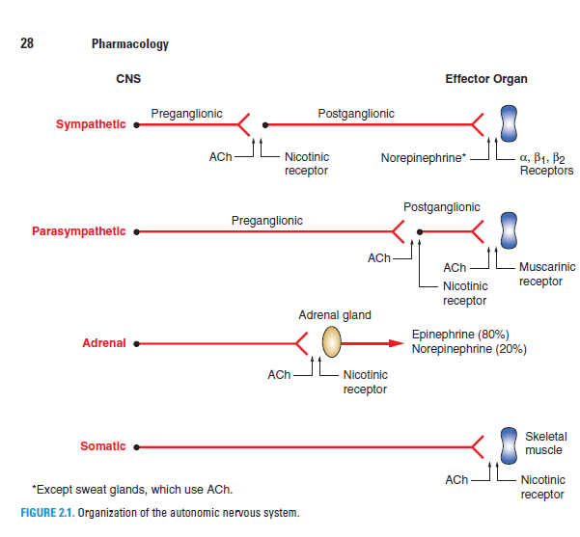

**Q) Give an example of an effector organ and discuss its autonomic effect on that organ.**

ANS effects on various organs of the body

|  |  |  |
| --- | --- | --- |
| **Organ** | **Sympathetic response** | **Parasympathetic response** |
| Eyes | Dilatation (α1) | Constriction |
| Heart | Increase heart rate (β1, β2) | Decrease heart rate |
| Increase contractility (β1, β2) | Decrease contractility |
| Increase conduction velocity | Decrease conduction velocity |
| Arterioles | Vasoconstriction (α) | Vasodilatation |
| Vasodilatation (β) |
| Systemic veins | Vasoconstriction (α) |  |
| Vasodilatation (β) |
| Lungs | Bronchodilatation (β2) | Bronchoconstriction |
| Kidney | Increase renin secretion (β1) |  |
| Gut | Decrease peristalsis and tone | Increase peristalsis and tone |
| Contraction of sphincter (α) | Relaxation of sphincter |
| Liver | Glycogenolysis (α1, β2) | Slight glycogen synthesis |
| Lipolysis |
| Bladder | Detrusor relaxation (β2) | Detrusor contraction |
| Sphincter contraction (α1) | Sphincter relaxation |
| Uterus | Contraction in pregnancy (α1) |  |
|  | Relaxation of pregnant and non-pregnant uterus (β2) |  |
| Basal metabolism | Increased |  |
| Adipose tissue | Lipolysis (α1, β1, β3) |  |
| Salivary glands | Thick, viscous secretion (α1) | Profuse, watery secretion |

**Q) Discuss the different types of adrenergic receptor**

α1 – post synaptic, Gq.

* Vasocontriction of blood vessels, contraction of smooth muscle, gluconeogenesis.

α2 – pre synaptic, Gi.

* Inhibits norad release, inhibits insulin release.

β1- postsynaptic, Gs.

* Increase HR, increase myocardial contractility, lipolysis.

β2- post synaptic, Gs

* Vasodilation, bronchodilation, glycogenolysis, glucagon release, relaxes uterine smooth muscle.

**Q) Compare and contrast the actions of adrenaline and noradrenaline on each of the different types of adrenergic receptor**

α1- norad >> adr

α2- adr > norad

β1- norad=adr

β2- adr >> norad

**Q) Discuss the baroreceptor reflex**

The vasomotor centre in the medulla controls sympathetic tone, the efferent arm of the reflex involving the baroreceptors in the maintenance of blood pressure. Baroreceptors are stretch receptors in the carotid sinuses and aortic arch. They are stimulated by an increase in transmural pressure as greater volumes of blood pass through the vessel. The sensory arm of the reflex runs in the glossopharyngeal and vagus nerves.

Fibres relay in the nucleus of the tractus solitarius where they release glutamate. An inhibitory pathway passes from the nucleus to the vasomotor area, where GABAminergic neurones inhibit the impulses in the vasomotor nerves.

Increasing blood volume passing the baroreceptors, therefore, produces vasodilatation and reduces venous return in order to maintain pressure. There is phasic activity in this reflex during the cardiac cycle.